**Project Design Phase-II**

**Data Flow Diagram & User Stories**

|  |  |
| --- | --- |
| Date | 15 October 2022 |
| Team ID | PNT2022TMID12589 |
| Project Name | Project – News Tracker Application |
| Maximum Marks | 4 Marks |

**Data Flow Diagrams:**

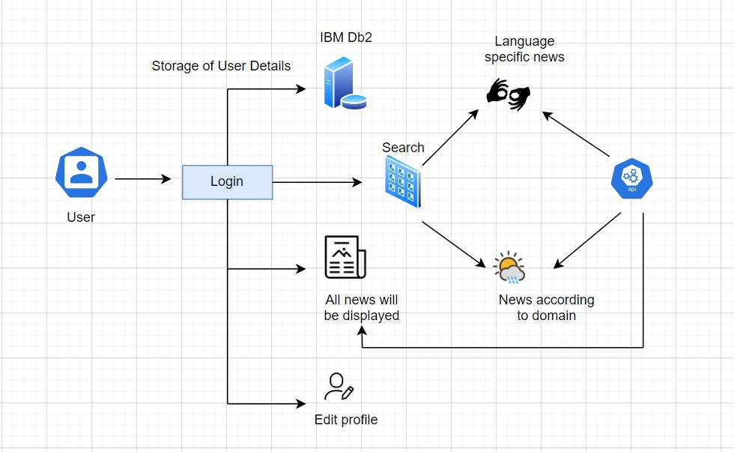

**User Stories**

|  |  |  |  |  |  |  |
| --- | --- | --- | --- | --- | --- | --- |
| **User Type** | **Functional**  **Requirement (Epic)** | **User Story**  **Number** | **User Story / Task** | **Acceptance criteria** | **Priority** | **Release** |
| Customer (web user) | Registration | USN-1 | As a user, I can register for the application by entering my username, password and email. | I can access my account / dashboard | High | Sprint-1 |
|  | Login | USN-2 | As a user, I can log into the application by entering username & password. | I can access my account / dashboard | High | Sprint-1 |
|  | Display all news | USN-3 | As a user, I can view all day-to-day news. | News fetched from an API can be viewed | High | Sprint-2 |
|  | News based on  filter | USN-4 | As a user, I can view based on the search/filter. | News related to filter will be fetched and displayed | High | Sprint-3 |
|  | Edit Profile | USN-5 | As a user, I can edit my profile details. | Updated details are stored in the database | Medium | Sprint-2 |
|  | Logout | USN-6 | As a user, I can log out | I will be redirected to login page | High | Sprint-1 |